JUnit Programs (Experiments 16–35)
16.JUnit Program to Check Anagram Strings
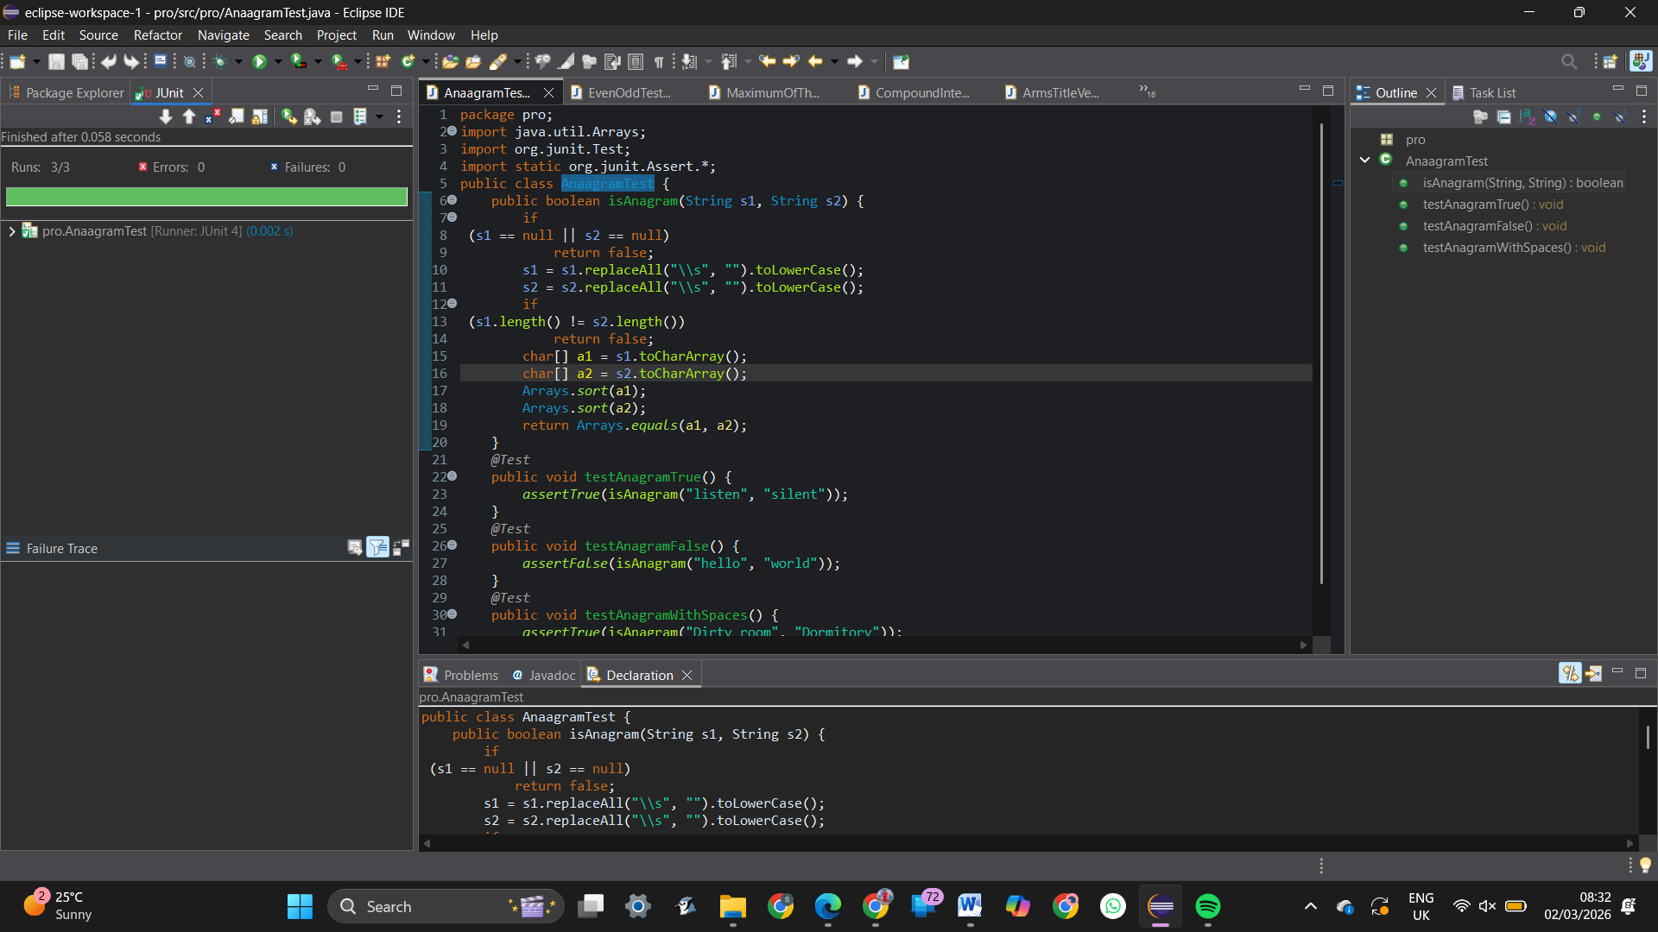
17.JUnit Program to Find Maximum of Three Numbers
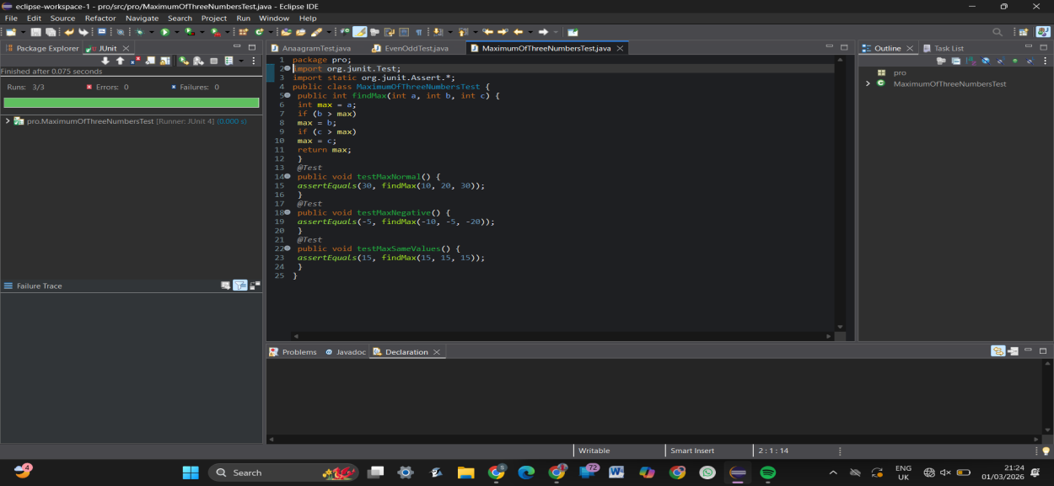
18.Junit Program to Check Even or Odd Number 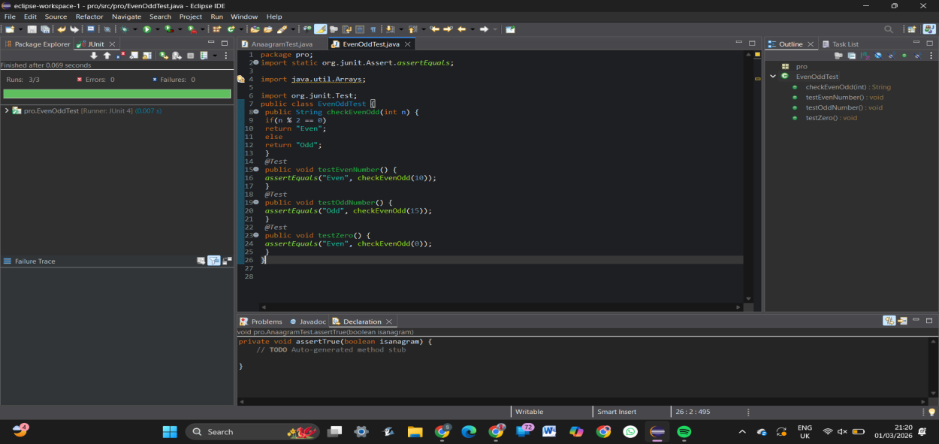

19.Compound Interest Calculation Using JUnit
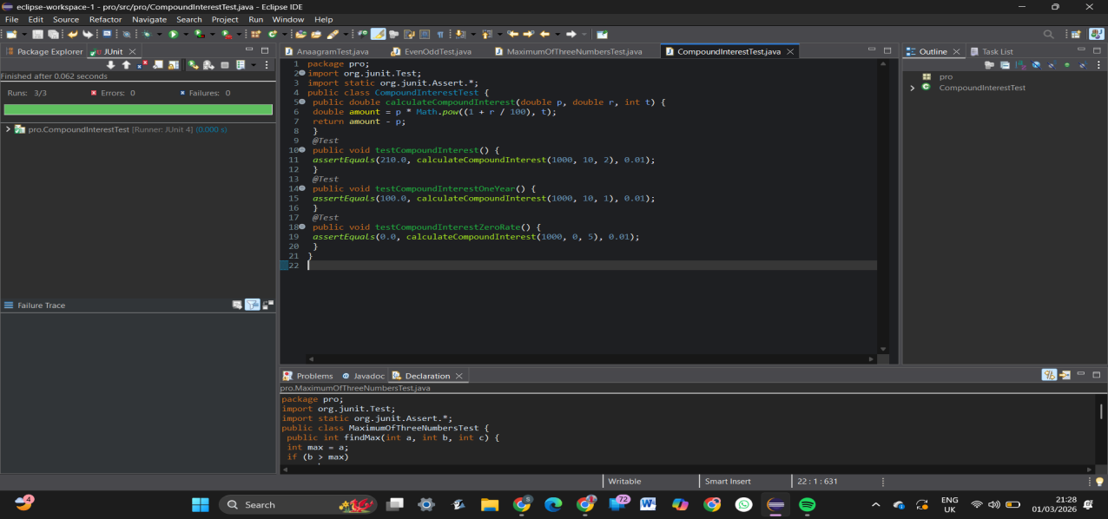
20.Count Vowels and Consonants Using JUnit
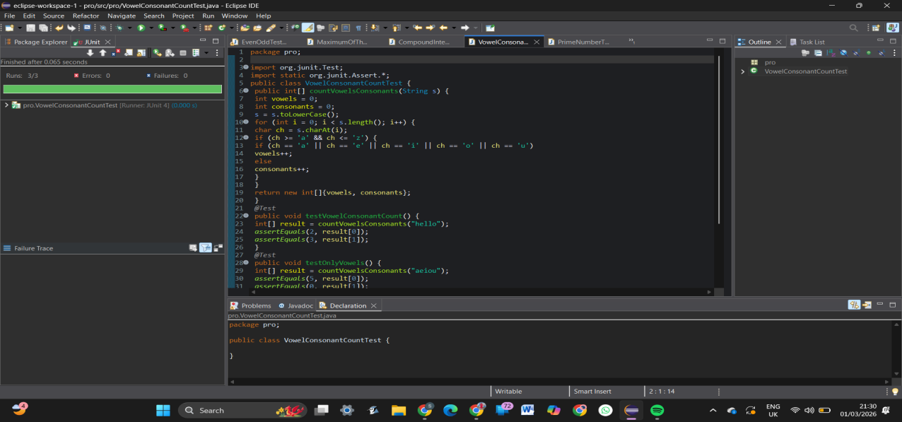
21.Prime Number Checking Using JUnit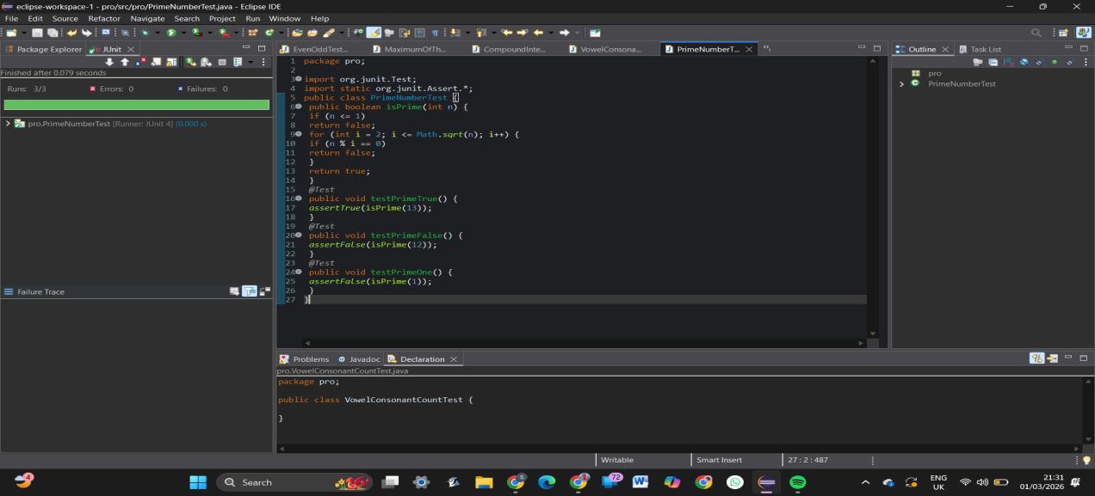
22.Reverse a Number Using JUnit
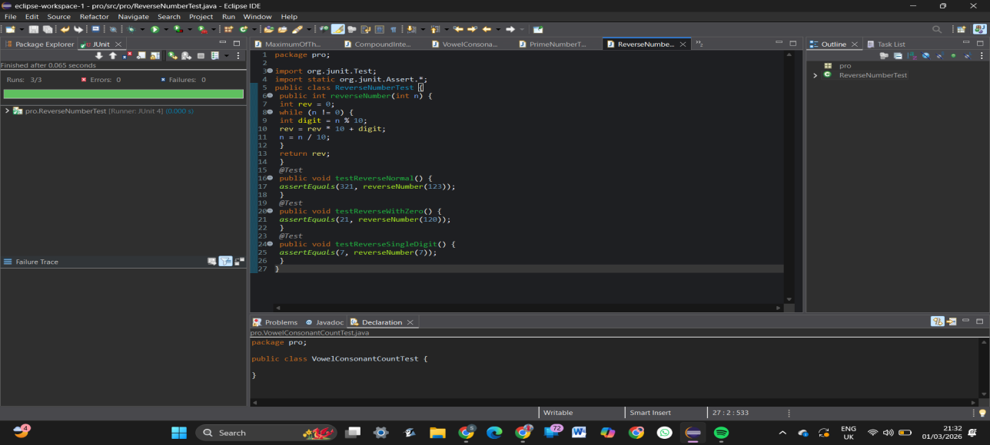
23.Sum of Digits of a Number Using JUnit
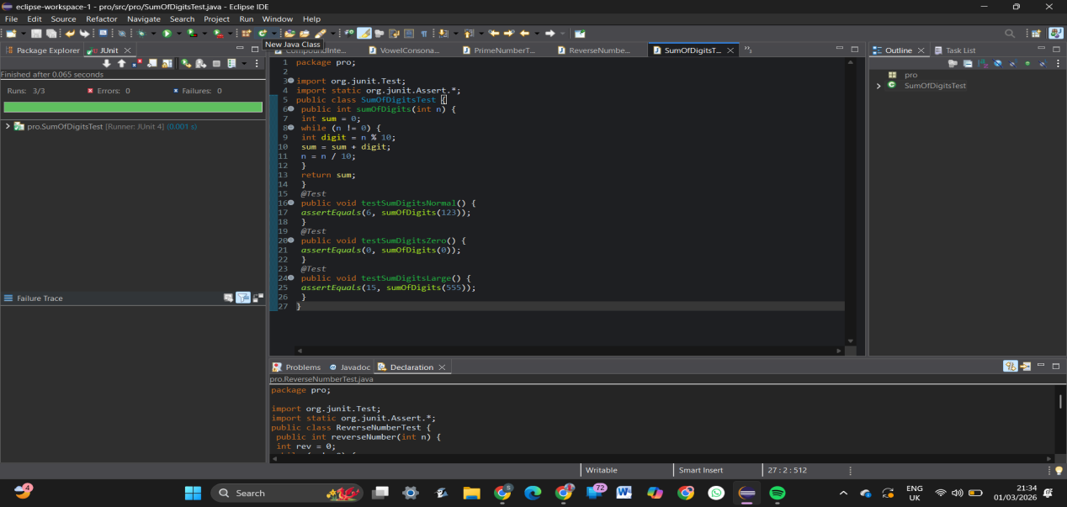
24.String Equality Ignoring Case Using JUnit
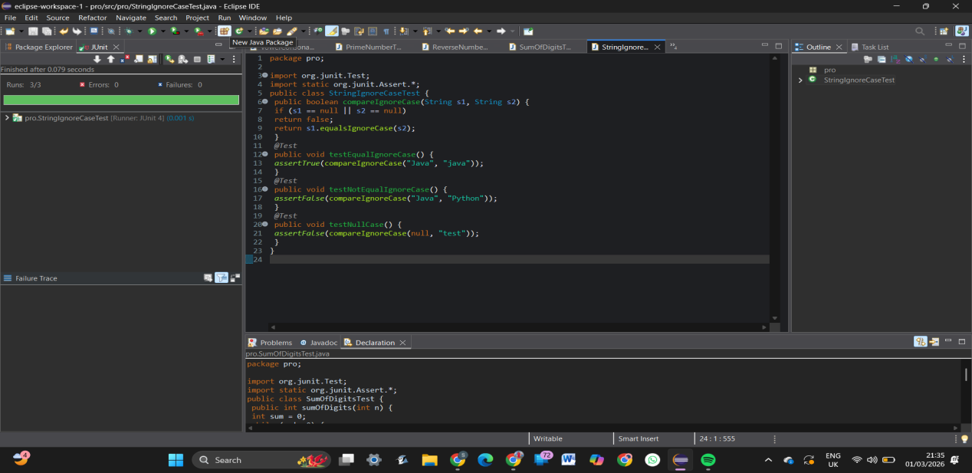
25.Student Grade Calculation Using JUnit
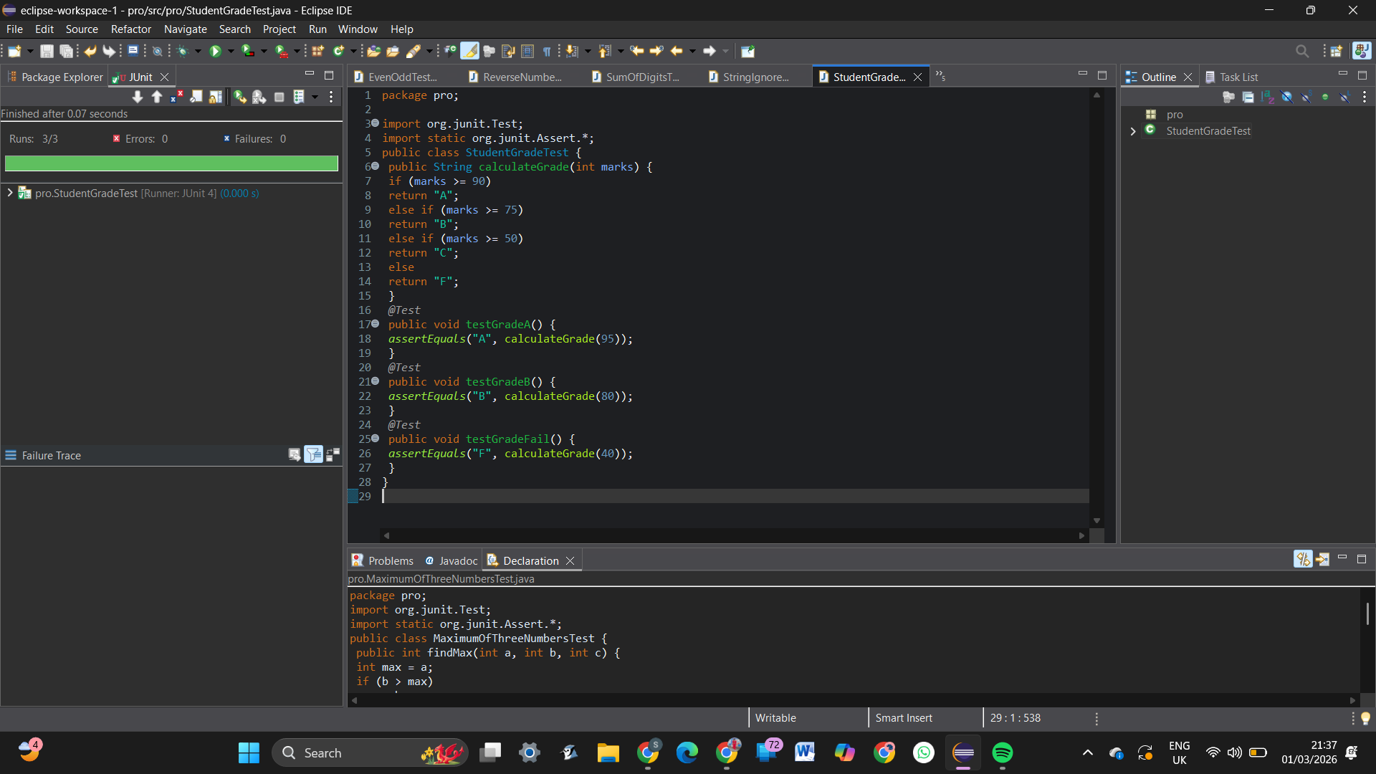
26.Find Largest Element in an Array Using JUnit
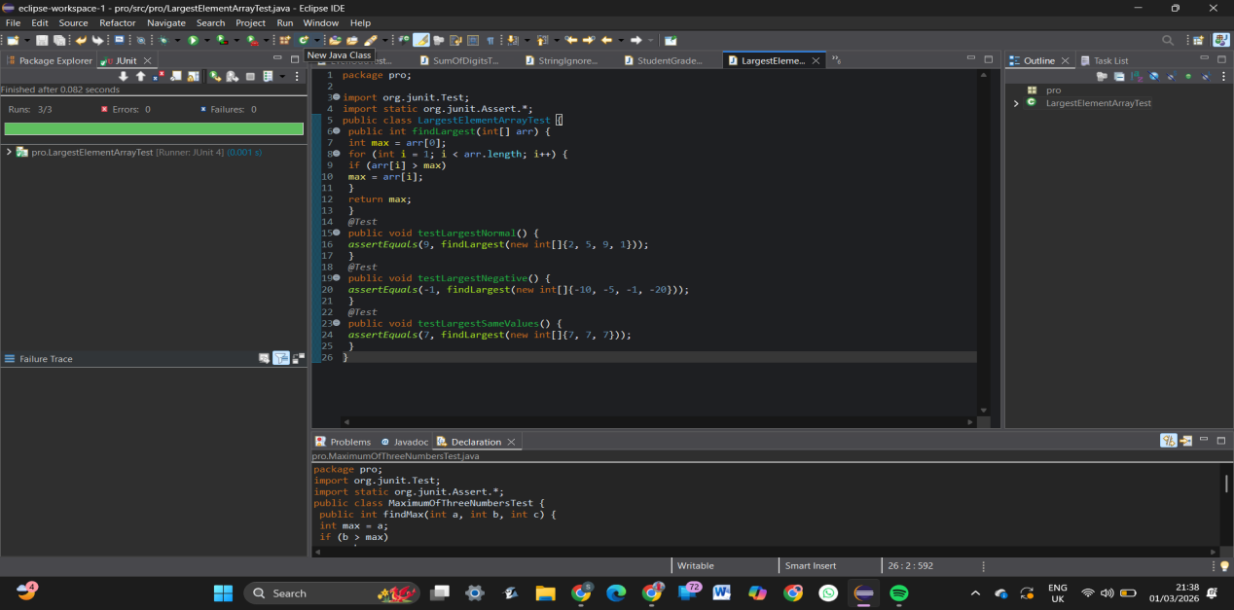
27.Calculate Average of N Numbers Using JUnit
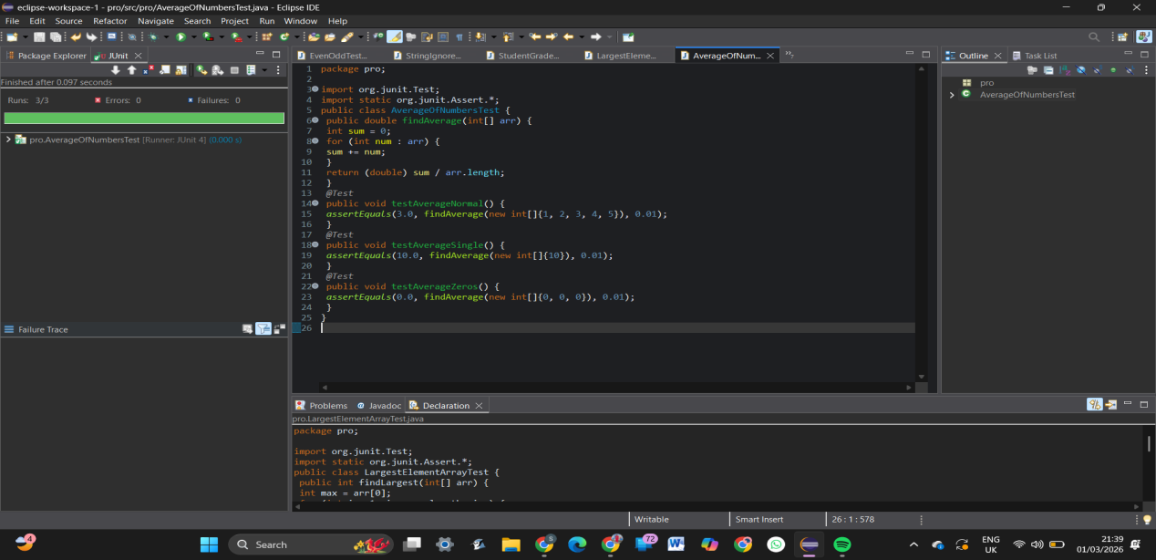
28.Check Armstrong Number Using JUnit
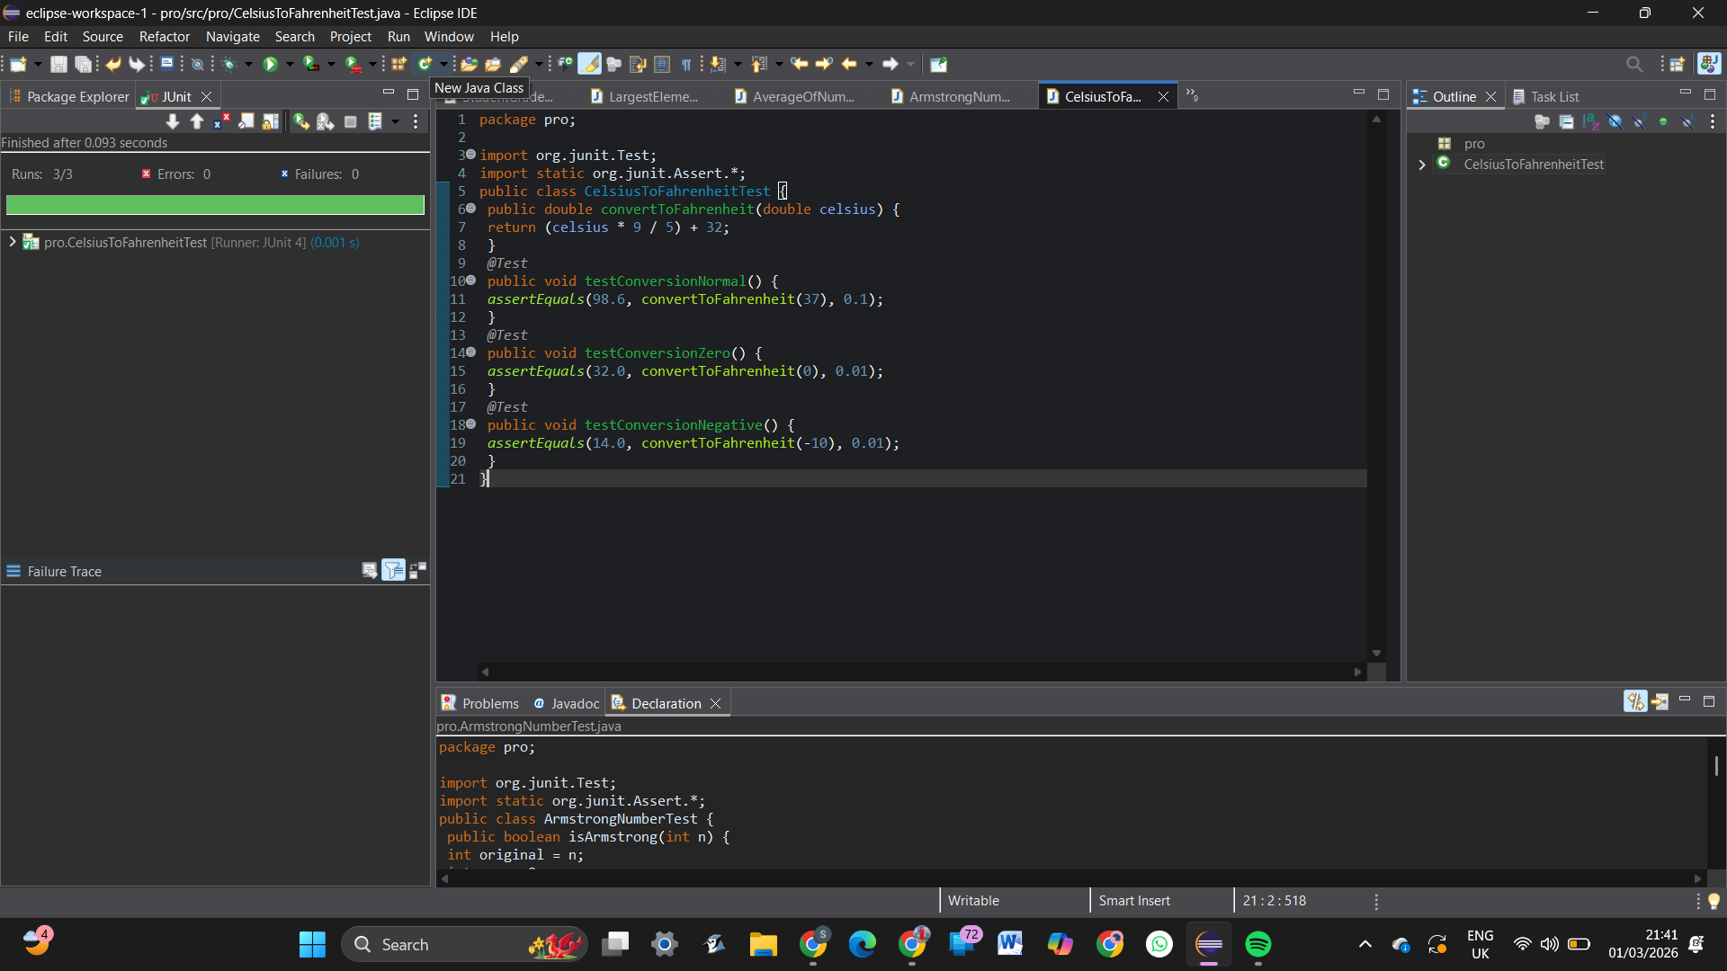
29.Convert Celsius to Fahrenheit Using JUnit
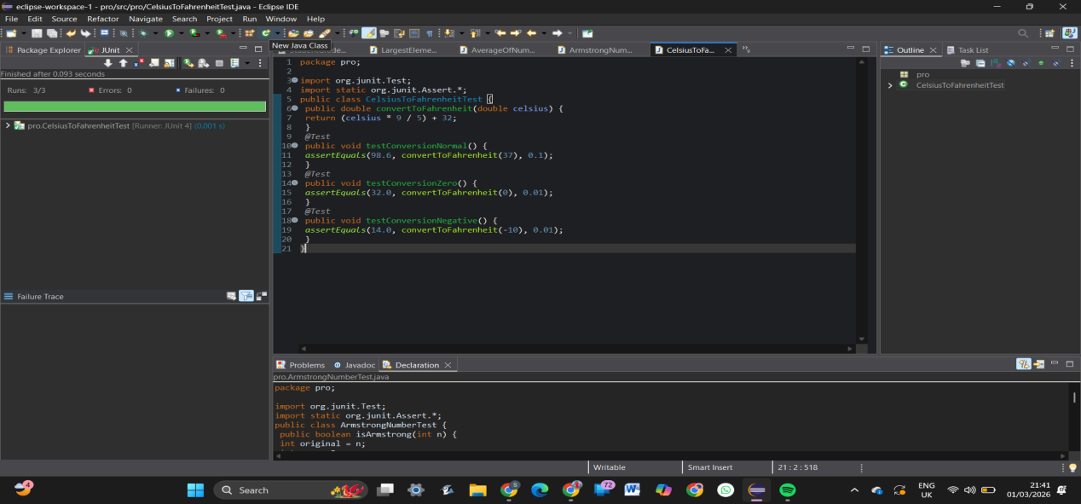
30.Find Length of a String Without Built-in Function Using JUnit
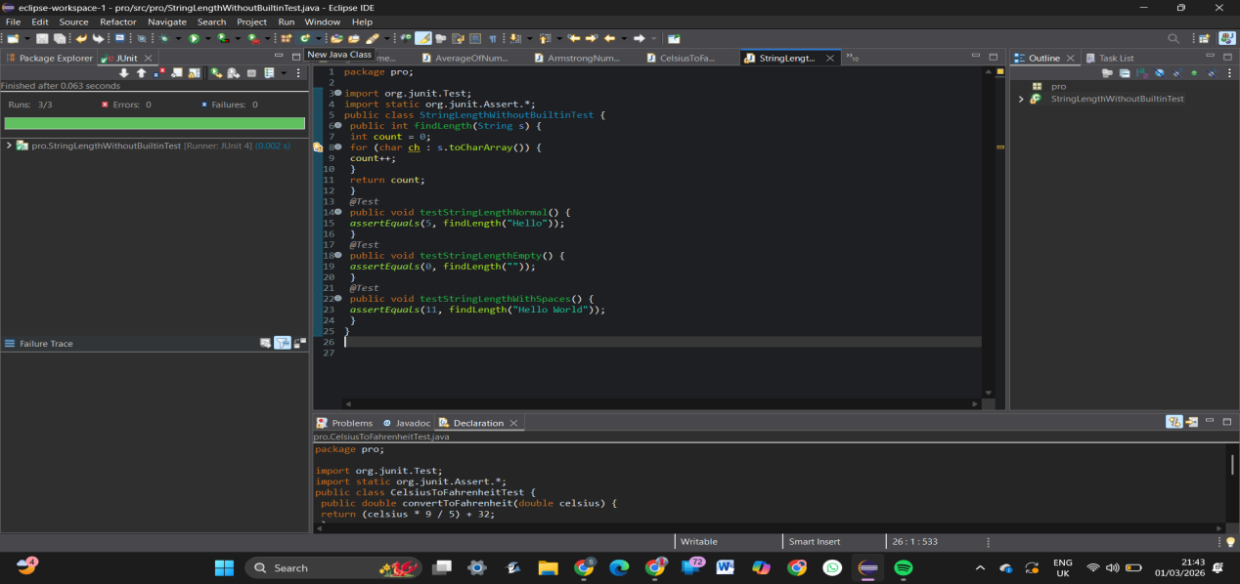
31.Reverse a Word Using JUnit
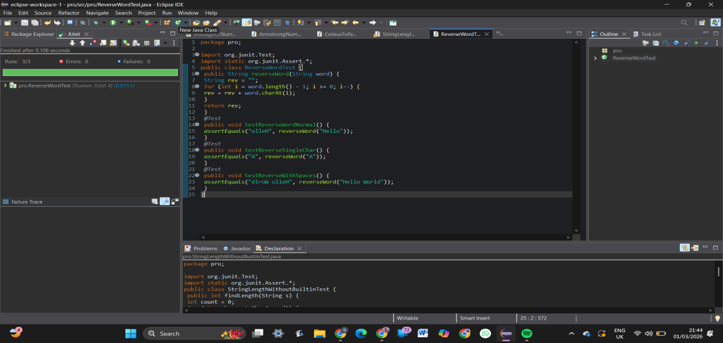
32.String Comparison Using JUnit
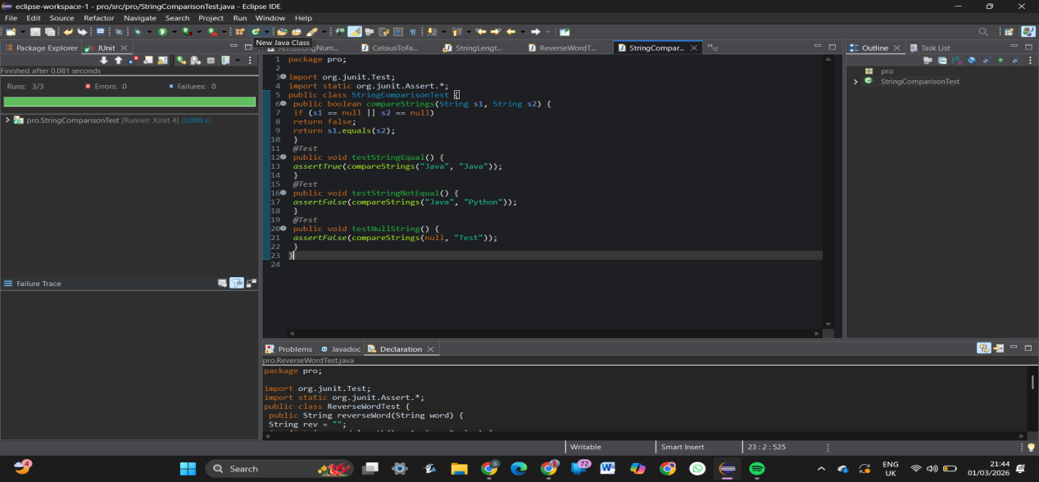
33.Voting System Using JUnit
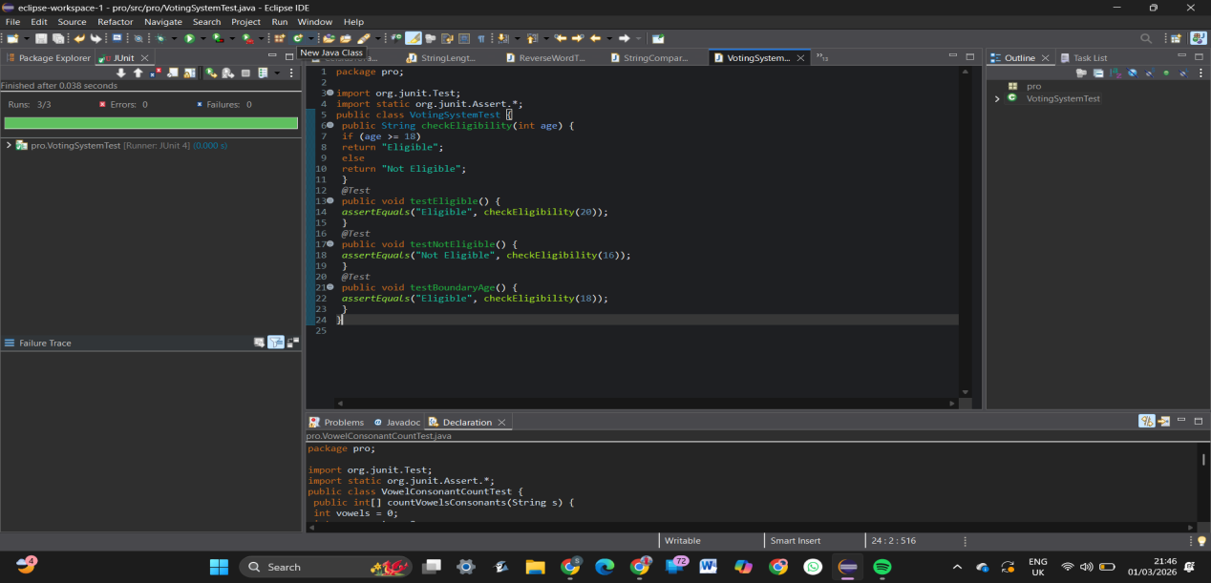
34.Simple Interest Calculation (Senior Citizen) Using JUnit
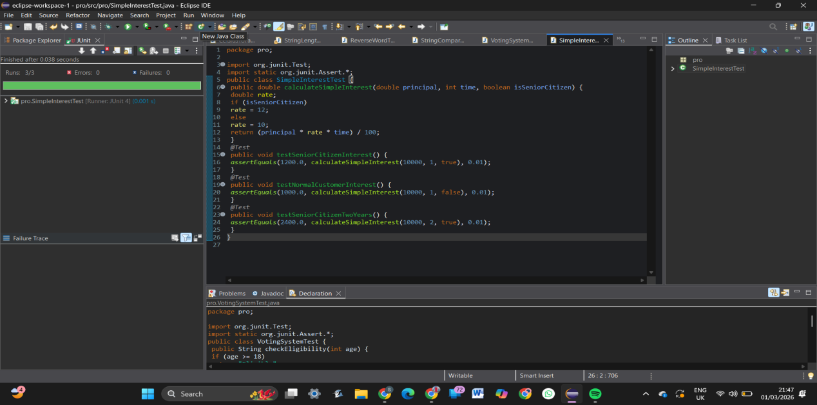
35.Palindrome Number Check Using JUnit